Contents
Day01 Advanced JavaScript 2
Section 1 – CONNECTING TO THE APIS THE OLD WAY 2
Section 2 – The New Way 4
Section 3 – Display the Data 6
Section 4 – using the APIs 7
Section 5 – using the Ultra modern async/await 7

Day01 Advanced JavaScript

Section 1 – CONNECTING TO THE APIS THE OLD WAY

- We will be using mainly the teamweights.html file to connect to our back end API and display the data we have collected so far. Hook up this html file to our .js file just like we did for enterweight.html.
- From the main div, remove all the dummy text and just include a div to display the data and a button to call a function to get the data
<div id="container">
<div id="main">
<div id="mainContent">
<h2>Showing records for team</h2>
<div id="records"></div>
<button onclick="getData();">Get Records</button>
</div>
<div id="aside">

- In the scripts.js file we can start writing the getData() function, put this code at the top of the document:
let pTags = document.getElementsByTagName('p');
let xmlhttp = new XMLHttpRequest();
let file = "json.txt";
function getData(){

}

- In the function get ready to access the XMLHttpRequest object we just included in the file:
let file = "json.txt";
function getData(){
xmlhttp.onreadystatechange = function() {

}
}

Notice the onreaddystatechange property of the xmlhttp object takes a function, we will define that function now
- We first check the readyState of the onreadystatechange property and the status for specific numbers, if these are satisfied, we proceed to get the data via responseText
function getData(){
xmlhttp.onreadystatechange = function() {
if (this.readyState == 4 && this.status == 200) {
console.log(JSON.parse(this.responseText));
}
}
}

- After this we need to invoke the open() method as well as the send() method of the XMLHttpRequest object.
function getData(){
xmlhttp.onreadystatechange = function() {
if (this.readyState == 4 && this.status == 200) {
console.log(JSON.parse(this.responseText));
}
}
xmlhttp.open("GET", file, false);
xmlhttp.send(null);
}

If all goes well, we should see the data in the console window of the browser
You may see a parsing error, but this has to do with browser security, ignore it for now
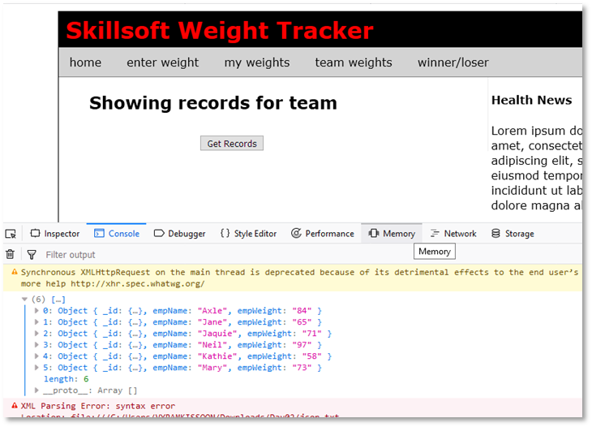

Here is the top part of the scripts.js file so far
let xmlhttp = new XMLHttpRequest();
let file = "json.txt";
function getData(){
xmlhttp.onreadystatechange = function() {
if (this.readyState == 4 && this.status == 200) {
console.log(JSON.parse(this.responseText));
}
}
xmlhttp.open("GET", file, false);
xmlhttp.send(null);
}
//
function validateForm(){ ……..

Section 2 – The New Way
- We now use the fetch() method to do the same thing we just did using the old ajax way. In the end, fetch() uses ajax in the background.
- All we have to do is change the getData() function to this below. Everything else remains the same:
function getData(){
fetch(file);
}

- Fetch returns an object, a promise object and the only way to handle that is with a then() method chained to the fetch() method.
function getData(){
fetch(file).then();
}

- Now within that then method, you have to supply a function that will handle any response from the fetch call.
function getData(){
fetch(file).then(function(){
console.log();
});
}

- With this structure, we can now work with whatever response comes from the fetch call, meaning the response.
function getData(){
fetch(file).then(function(response){
console.log(response);
});
}

- The problem with this response is that it returns everything the server reported, we are only interested in the data.
function getData(){
fetch(file).then(function(response){
console.log(response);
});
}

- Instead of just logging the response, lets return the response, but return it as JSON.
function getData(){
fetch(file).then(function(response){
return response.json();
});
}

- The problem is now that the return is now a promise as well, so we need another then() method to interpret that response.
function getData(){
fetch(file).then(function(response){
return response.json().then();
});
}

- Just like before, the then method has to have a function to handle the json response
function getData(){
fetch(file).then(function(response){
return response.json().then(function(){});
});
}

- Finally we can pass the JSON object through this new anonymous function and from there we can use the data any how we wish. Just like before, the then() method has to have a function to handle the json response
function getData(){
fetch(file).then(function(response){
return response.json().then(function(jData){console.log(jData);});
});
}

It should show the same data in the console window. In this function, the fetch() method first returns a promise which is handled by the then() method that is chained to the fetch() method.
The first then() method extracts the data out of response and returns it as JSON to the next then() method. That second then method uses a function to pass JSON data back to the calling function, in this case it is the console window.

- Usually though it is better to write the code in a more structured way:
function getData(){
fetch(file).then(function(response){
return response.json().then(
function(jData){
console.log(jData);
}
);
});
}

- This way we can complete the function by also inserting a catch method, just in case anything went wrong. In this way we say that the catch() method is chained to the then() method which is chained to the fetch() method.
function getData(){
fetch(file)
.then(function(response){
return response.json().then(
function(jData){
console.log(jData);
}
)
.catch(function(error){
console.log(error);
});
});
}

- Using arrow functions
function getData(){
fetch(file)
.then(response => response.json())
.then(response => console.log(response))
.catch(error => console.log(error));
};

Section 3 – Display the Data
- Remember we had a div tag in the teamweights.html file that we can use to display the data, this div has an id of records. We will use the innerHTML of this tag to display the data.
- In the scripts.js file add a new function just beneath the getData() function, called displayData()
function displayData(arr) {
let outHTML = "";

document.getElementById("records").innerHTML = outHTML;
}

Notice that outHTML is a new variable which we will use to append records as we iterate through the array containing our data lines.
- The data in the console showed up as an array so we need an array structure to get the data out
function displayData(arr) {
let outHTML = "";
for(let i=0; i < arr.length; i++){
outHTML+="<p>"+arr[i].empName + " weighed " + arr[i].empWeight + " Kgs</p>";
}
document.getElementById("records").innerHTML = outHTML;
}

- Now call this function displayData() from the getData() function, via its then() method.
function getData(){
fetch(file)
.then(response => response.json())
.then(response => displayData(response))
.catch(error => console.log(error));
};

- What if you also wanted to log the data. As it turns out we could have multiple then() methods in a structure. But because we already used the response within a function, we would have to manually pass it to the next chained event by using a return statement.
function getData(){
fetch(file)
.then(response => response.json())
.then(response => {
displayData(response);
return response;
})
.then(response =>console.log(response))
.catch(error => console.log(error));
};

Section 4 – using the APIs
- In order to connect and consume the API, add the url address as a new variable in the scripts.js file. Then fetch the url instead of the file.
let xmlhttp = new XMLHttpRequest();
let file = "json.txt";
let url = "http://localhost:8000/getallrecords";
function getData(){
fetch(url)

Note, both the database and the node server file must be started for this to work.
The CORS plugin must be turned on to allow requests from the same domain.

Section 5 – using the Ultra modern async/await
In order to use the async/await method, we first have to make the getData() function an async function. After that we await the results of a fetch() operation which just like before returns a response object. We would need to apply await again in order to extract the json object from the response object.

async function getData(){
const response = await fetch(url);
const json = await response.json();
displayData(json);
}

With error handling:
async function getData(){
try{
const response = await fetch(url);
const json = await response.json();
displayData(json);
} catch(err){
console.log(err);
}
};

Here is the entire js file so far:
let xmlhttp = new XMLHttpRequest();
let file = "json.txt";
let url = "http://localhost:8000/getallrecords";
async function getData(){
try{
const response = await fetch(url);
const json = await response.json();
displayData(json);
} catch(err){
console.log(err);
}
};
//
function displayData(arr) {
let outHTML = "";
for(let i=0; i < arr.length; i++){
outHTML+="<p>"+arr[i].empName + " weighed " + arr[i].empWeight + " Kgs</p>";
}
document.getElementById("records").innerHTML = outHTML;
}
//
function validateForm(){
document.getElementById("nameMessage").innerHTML="";
document.getElementById("weightMessage").innerHTML="";
let badName = /^([^0-9]*)$/;
let empName = document.forms["frmCollectWeights"]["empName"];
let empWeight = document.forms["frmCollectWeights"]["empWeight"];
if (empName.value == "") {
document.getElementById("nameMessage").innerHTML="Name cannot be empty!";
empName.focus();
return false;
}
if (empName.value.length < 3 && empName.value != "") {
document.getElementById("nameMessage").innerHTML="Name too short!";
empName.focus();
return false;
}
if (!empName.value.match(badName)) {
document.getElementById("nameMessage").innerHTML="Name cannot contain numbers!";
empName.focus();
return false;
}
//
if (empWeight.value == "") {
document.getElementById("weightMessage").innerHTML="Weight cannot be empty!";
empName.focus();
return false;
}
if (isNaN(empWeight.value)) {
document.getElementById("weightMessage").innerHTML="Weight must be a number";
empWeight.focus();
return false;
}

//
return true;
}
//
let pTags = document.getElementsByTagName('p');
for(let i = 0; i < pTags.length; i++) {
pTags[i].addEventListener('mouseover', function(){
this.style.backgroundColor='lightyellow';
}, false);
pTags[i].addEventListener('mouseout', function(){
this.style.backgroundColor='';
}, false);
};
//
let inputTags = document.getElementsByTagName('input');
for(let i = 0; i < inputTags.length; i++) {
inputTags[i].addEventListener('focus', function(){
this.style.backgroundColor='lightyellow';
}, false);
inputTags[i].addEventListener('blur', function(){
this.style.backgroundColor='';
}, false);
};
//

